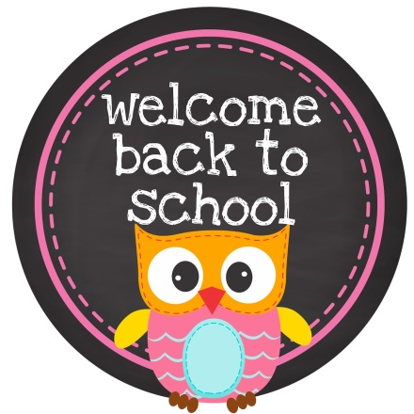
Hondo Valley Public Schools
2nd Grade
Ms. Stepp’s Classroom Supply List 2020

- 1 2” binder
- 1 bottle of glue
- 1 box of Kleenex
- Clorox wipes
- 1 box of 24 crayons
- 1 package of colored pencils
- 1 small crayon box to held pencils, crayons, etc.
- 1 package of colored markers
- 1 re-useable water bottle
- 1 package of assorted ballpoint pens
- 3 composition notebooks (NO SPIRALS PLEASE)
- Earbuds/headphones
- Water bottle
- Clorox wipes
- $15.00 Activity Fee

