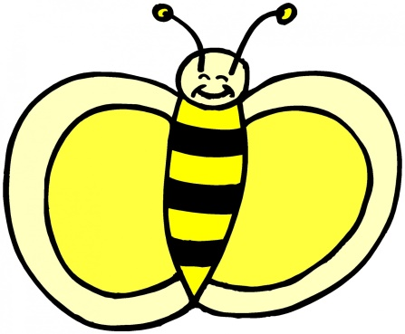Hondo Kindergarten
Mrs. Narvaez’s BEE’s

- (1) 32 Count Crayola Crayons
- (1) Decorative Duct Tape
- (1) Pk. Color pencils
- (1) Clorox Wipes
- (1) 4 oz. Elmer's Glue
- (3) small glue sticks
- (2) yellow highlighters
- (1) small box of Kleenex tissues
- (1) backpack-no wheels (please put name)
10.(1) basic plastic crayon/pencil box
11.(1) Leakproof water bottle
12.(1) Pk. Washable large grip markers
13.(1) 2 pocket folder without brads

“If it is to BEE, it is up to ME”

